**CMR** **University**



**Project Report**

**Facial Recognition System**

**Tool to manage Attendance using facial recognition**

***Submitted in partial fulfillment of the requirements***

***For the award of the degree***

**Bachelor of Computer Application**

**(VI Semester)**

**DEVELOPED BY**

|  |  |  |
| --- | --- | --- |
| **Name: Mithun K**  **Reg No: xxxxxx** | **Name: Jean Trevor**  **Reg No: 21DBCAG050** | **Name: Ekansh**  **Reg No: xxxxxxx** |

**GUIDED BY**

|  |  |
| --- | --- |
| **Prof. Mohan Reddy.Y**  Assistant Professor,  SSCS, CMRU, Bangalore | **Prof. Prof.Aurangjeb Khan**  Assistant Professor,  SSCS, CMRU, Bangalore |

**2021 – 2024**

**School of Science and Computer Studies**

*#*5, Bhuvanagiri, OMBR Layout, Bangalore- 560 043, Karnataka – India

**CMR** **University**



Certificate

This is to certify that Jean Trevor and **21DBCAG050** Belonging to **VI Semester, BCA** course has satisfactorily completed the project titled **“Facial Recognition System”** in partial fulfillment of Practical prescribed by the School of Science and Computer Studies for the Course code **------------------** and Course name Capstone during the academic year 2021 – 2024

|  |  |  |
| --- | --- | --- |
| <Prof name>  Project Guide | <Prof name>  Program Coordinator | <Prof name>  Director |

**SEAL:**

**Name: Jean Trevor**

**Name: Jean Trevor**

**Reg No: 21DBCAG050**

**Date of Practical Examination: 21/05/2024**

**School of Science and Computer Studies**

*#*5, Bhuvanagiri, OMBR Layout, Bangalore- 560 043, Karnataka - India

**CMR** **University**

Declaration

The project titled **Facial Recognition System** Developed by us in the partial fulfillment of **VI Semester, BCA** course, is an authentic work carried out by us under the guidance of **Prof. , Assistant Professor** School of Science and Computer Studies, CMR University, Bangalore.

We declare that the project has not been submitted to any degree or diploma to the above said university or any other university.

Signature: ………………………………………

**Name: Jean Trevor**

**Reg No: 21DBCAG050**

I certify that all the above statements given by the candidate are true to the best of my knowledge and belief.

Signature: ………………………………………

**Prof.**

**Project Guide**

**School of Science and Computer Studies**

*#*5, Bhuvanagiri, OMBR Layout, Bangalore- 560 043, Karnataka – India

**ACKNOWLEDGEMENT**

We take this opportunity to express our gratitude to all those who have given their moral support during our entire project.

Firstly, we wish to express our profound thanks to **Dr. Sabita Ramamurthy**, Chancellor, CMR University, Bangalore, for providing us all the facilities required in completion of our project.

I am greatly indebted to **Dr. ………………………** Director, School of Science Studies, Bangalore, for her encouragement and suggestion at every step of our project work.

Our Sincere thanks to **Prof. ………………………** project guide, without whom this project is unimaginable, for guiding us with keen interest and constant encouragement at every stage during the course of our project work.

Finally, yet importantly, we want to thank all our friends and our family members who have helped us directly or indirectly in the successful completion of this project.

**Name: Jean Trevor**

**Reg No: 21DBCAG050**

**CONTENTS**

1. **Introduction 1**
2. **Objectives 3**
3. **System analysis**

**3.1 Identification of the Need**

**3.2 Preliminary Investigation**

**3.3 Pert Chart**

**3.4 Gantt Chart**

**3.5 Feasibility Study**

1. **Technical Feasibility**
2. **Economical Feasibility**
3. **Operational Feasibility**
4. **SDLC (Software Development Life Cycle)**
5. **SRS (Software Requirement Specification)**
6. **Module Description**

**7. Design**

**7.1 DFD**

**7.2 ER Diagram**

**7.3 Form Design/Snap shot**

**8. Coding**

**9. Testing**

1. **Data validation checks**
2. **Implementation**
3. **Security measures taken**
4. **Cost estimation of the project**
5. **Maintenance**
6. **Limitation**

**15.1 future enhancement**

1. **Bibliography**

**1. Introduction**

**FACIAL RECOGNITION ATTENDANCE SYSTEM**

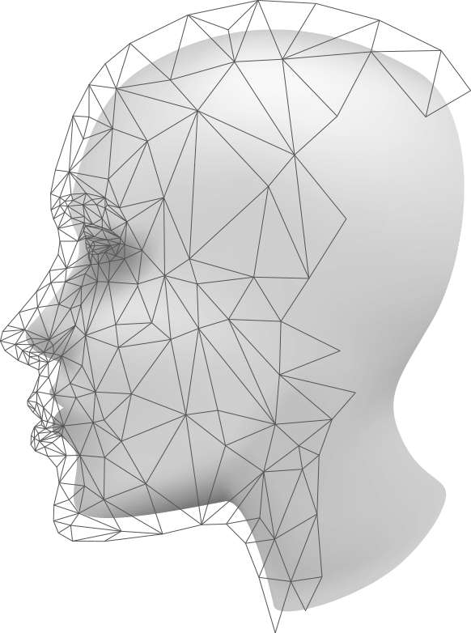

Everything in the current era has become contactless, from financial transactions to education. Things are carried out without any physical interaction, whether it’s making payments to someone or purchasing anything for your business. So, don’t you think the same cutting-edge contactless technology should be applied to attendance management?

The attendance management system has various advantages. Automated attendance solutions have come a long way, from saving time to making things more comfortable.

In the current situation, contactless attendance system using face recognition is an efficient preventive strategy since they allow for a safe and efficient way of marking entry in and out.  In terms of its most recent version,[**facial recognition technology**](https://www.grandviewresearch.com/industry-analysis/facial-recognition-market)has made recording attendance simpler than ever before.

A facial recognition attendance system automatically identifies and confirms a person and records attendance based on their face detection. Face recognition attendance systems are catching the attention of both small and large businesses. It’s no wonder that such **face recognition-based attendance systems** are becoming more popular in workplaces due to their wide range of advantages.

A facial recognition attendance system incorporates facial recognition technology to recognize and verify facial features and to record attendance automatically. Face detection attendance system detects faces and marks attendance.

Unlike other forms of biometric technology, such as fingerprint recognition, which captures identity by touching, a face recognition-based attendance system manages employees without the approach of direct contact. Face recognition attendance system records the field employee’s attendance marking time and geolocation. A touchless method such as a face recognition-based attendance system is a successful preventive measure during the COVID-19 epidemic.

**2. Objectives**

Facial recognition attendance systems are employed to achieve several objectives in various settings, including workplaces, schools, and even events. Here are some of their primary goals:

**Enhanced Accuracy and Efficiency:**

**Reduced Buddy Punching:** facial recognition attendance system aims to eliminate the practice of "buddy punching," where one employee clocks in or out on behalf of another, leading to inaccurate attendance records.

**Automatic Attendance Tracking:** By automating the attendance-taking process, facial recognition attendance system can save time and resources compared to manual methods.

**Minimize Human Error:** Manual attendance recording is prone to errors due to forgetting to sign in or out, or making mistakes during data entry. facial recognition attendance system can help minimize these human errors.

**Time-saving:** Facial recognition systems can quickly and accurately identify individuals without the need for manual input, reducing the time spent on traditional attendance methods

**Improved Security and Access Control:**

**Positive Identification:** Facial recognition provides a more secure method of identification compared to traditional methods like swiping ID cards, which can be easily lost or stolen.

**Restricted Access:** facial recognition attendance system can be integrated with access control systems to grant entry only to authorized individuals.

**Monitoring Attendance Patterns:** facial recognition attendance system can help identify unusual attendance patterns, potentially indicating lateness, absenteeism, or unauthorized access attempts.

**Streamlined Administration and Convenience:**

**Contactless Attendance:** facial recognition attendance system offers a contactless method of recording attendance, which can be beneficial in maintaining hygiene, especially during times of heightened health concerns.

**Faster Processing:** Facial recognition technology allows for quick and efficient identification and attendance recording.

**Remote Monitoring:** Some facial recognition attendance system offers the ability to remotely monitor attendance data, providing flexibility for managers and administrators.

It's important to note that the use of facial recognition attendance system also comes with ethical considerations and potential privacy concerns, which should be carefully weighed against the intended benefits before implementation.

**3. System analysis**

System analysis is the process of investigating a system to understand its goals, functionalities, and how it works. It's a way to identify areas for improvement or determine the feasibility of creating a new system. Here's a breakdown of key aspects of system analysis:

**Objectives:**

* **Understanding the System:** System analysts delve into the existing system's components, processes, data flows, and interactions with users.
* **Identifying Needs and Requirements:** They gather information about user needs, pain points, and desired functionalities for the system.
* **Evaluating System Effectiveness**: Analysts assess how well the current system meets user requirements and identify areas for improvement.

**3.1 Identification of the Need**

Facial recognition attendance systems are gaining popularity due to several advantages they offer over traditional methods like manual sign-in sheets or badge swiping.

Here's a breakdown of the key reasons why organizations are considering Facial recognition Attendance system:

**Increased Accuracy:** Facial recognition technology is highly accurate and reliable, making it difficult to impersonate another person.

**Enhanced Efficiency and Convenience:** Facial recognition Attendance system streamlines the attendance recording process, eliminating the need for manual entry or physical contact with a device. This saves time for both employees and administrators.

**Improved Hygiene and Contactless Attendance:** In the age of hygiene concerns, Facial recognition Attendance system eliminates the need to touch a shared surface like a fingerprint scanner or sign-in sheet, reducing the risk of germ transmission.

**Potential for Additional Features:** Some Facial recognition Attendance system can integrate with other systems, offering features like work location tracking, time tracking, and access control.

However, it's important to remember that Facial recognition Attendance system also raise concerns regarding privacy, security, and potential bias in facial recognition algorithms. It's crucial to carefully consider these factors and ensure compliance with relevant data privacy regulations before implementing such a system.

6**3.2 Preliminary Investigation**

A facial recognition system is a technology that can identify or verify a person's identity by comparing their face to a database of images. Here's a breakdown to get you started on your investigation:

**How it Works:**

**Facial Recognition Technology:** The system uses algorithms to map facial features from a captured image (like a camera or video). These features include the distance between your eyes, the shape of your jaw, and the proportions of your nose.

**Matching:** The system then compares this information to a database of faces. This database can be private (used to unlock your phone) or public (used for law enforcement).

**Identification vs. Verification:** There are two main applications: identification (recognizing someone unknown) and verification (confirming someone's claimed identity).

**Benefits:**

**Security and Access Control:** Facial recognition can be used for secure access to devices, buildings, or restricted areas.

**Law Enforcement:** It can be a tool for identifying suspects or missing persons.

**Convenience**: It can be a fast and contactless way to verify identity for payments or other purposes.

**Other Applications:** There are emerging uses in healthcare (disease diagnosis) and marketing (targeted advertising).

**Considerations:**

**Privacy Concerns:** The use of facial recognition, especially by governments, raises concerns about mass surveillance and potential misuse of personal data.

**Accuracy:** Facial recognition technology is not perfect and can be fooled by factors like lighting, disguise, or facial expressions. Bias can also creep into algorithms if the training data is not diverse.

**Regulation:** There are ongoing discussions around regulations and ethical considerations regarding facial recognition use.

**Getting Started with your Investigation:**

**Define your Goals:** What problem are you trying to solve with facial recognition?

**Research Use Cases**: Explore how facial recognition is being used in different industries. There are success stories and cautionary tales to learn from.

**Understand the Technology:** Learn more about how facial recognition works, its limitations, and the different algorithms involved.

**Privacy and Ethics:** Consider the privacy implications and potential ethical concerns surrounding facial recognition use.

**Legal and Regulatory Landscape:** Research any existing laws or regulations that might impact your use case.

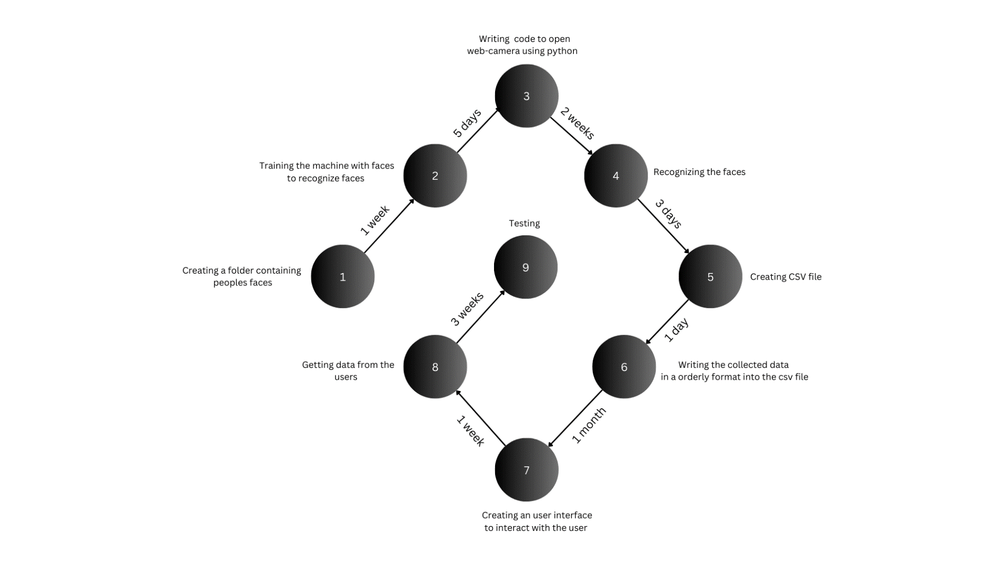**3.3 Pert Chart**

A PERT (Program Evaluation and Review Technique) chart is a visual tool that helps estimate project timelines and identify critical tasks. Here's a breakdown of a PERT chart for a facial recognition attendance system:

**Activities:**

Requirement Gathering: Define needs, functionalities, and integrations.

Hardware Selection: Choose camera, facial recognition module, and processing unit.

**Software Development:**

**a. Facial Recognition Engine:** Develop or integrate facial recognition algorithms.

**b. User Interface:** Design user interface for registration, attendance marking, and reporting.

**c. Database Management:** Develop database schema for storing user information and attendance data.

**System Integration:** Integrate hardware and software components.

**Testing & Validation:** Conduct comprehensive testing of facial recognition accuracy, system performance, and security.

**Deployment & Training:** Deploy the system at designated locations and train users.

**Dependencies:**

Activity 2 can't start before Activity 1 is complete.

Activity 3 can start partially after Activity 1 (basic functionalities) and needs to be completed before Activity 4.

Activity 3a can be partially independent (core engine) but might require user interface elements (3b) for full functionality.

Activity 3b and 3c are dependent on each other.

Activity 4 depends on completion of all sub-activities in Activity 3.

Activity 5 depends on Activity 4 (a functional system).

Activity 6 depends on Activity 5 (a validated system).

**Benefits of using a PERT Chart:**

* Helps visualize project workflow and dependencies.
* Identifies critical activities for focused monitoring.
* Provides time estimates with some flexibility for uncertainties.
* **3.4 Gantt Chart**

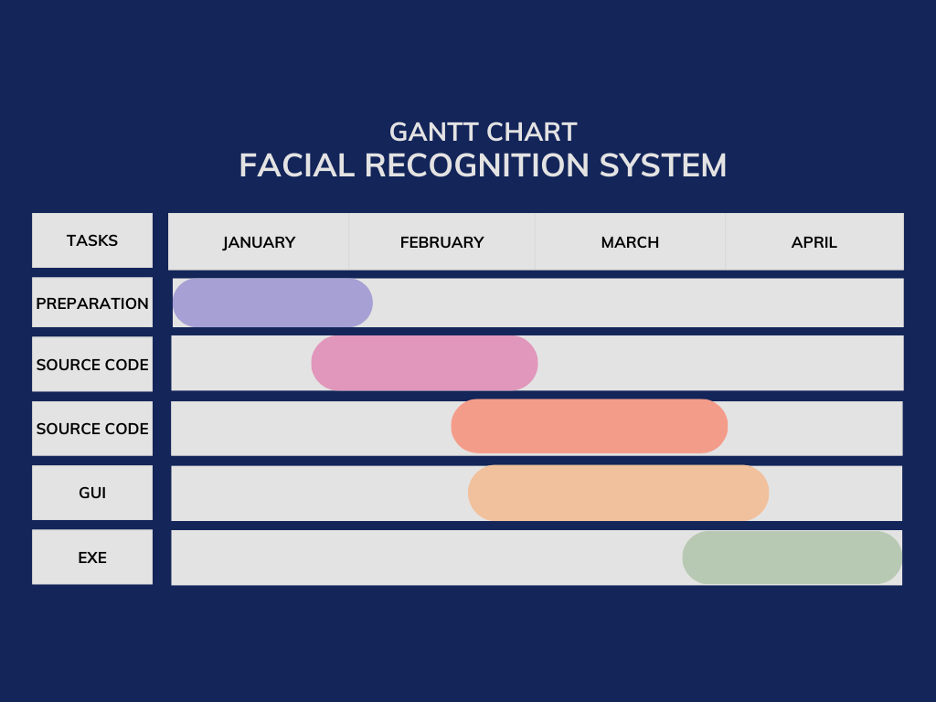

A Gantt chart is a fundamental project management tool used to visually represent a project's schedule over time. It essentially functions as a bar chart with two key components:

**Tasks:** Listed on the left side, these represent the individual activities that make up the entire project.

**Timeline:** Displayed on the right side, this is a horizontal scale representing the project's overall duration, typically divided into days, weeks, or month.

**4. Feasibility Study**

A feasibility study is a comprehensive assessment of a proposed project or system that evaluates all factors critical to its success. Its purpose is to determine the likelihood of success and identify potential issues before significant resources are committed. By conducting a thorough feasibility study, organizations can make informed decisions about their projects, increasing their chances of success and minimizing potential risks.

* 1. **Technical Feasibility**
  2. **Economical Feasibility**
  3. **Operational Feasibility**

**5. SDLC (Software Development Life Cycle)**

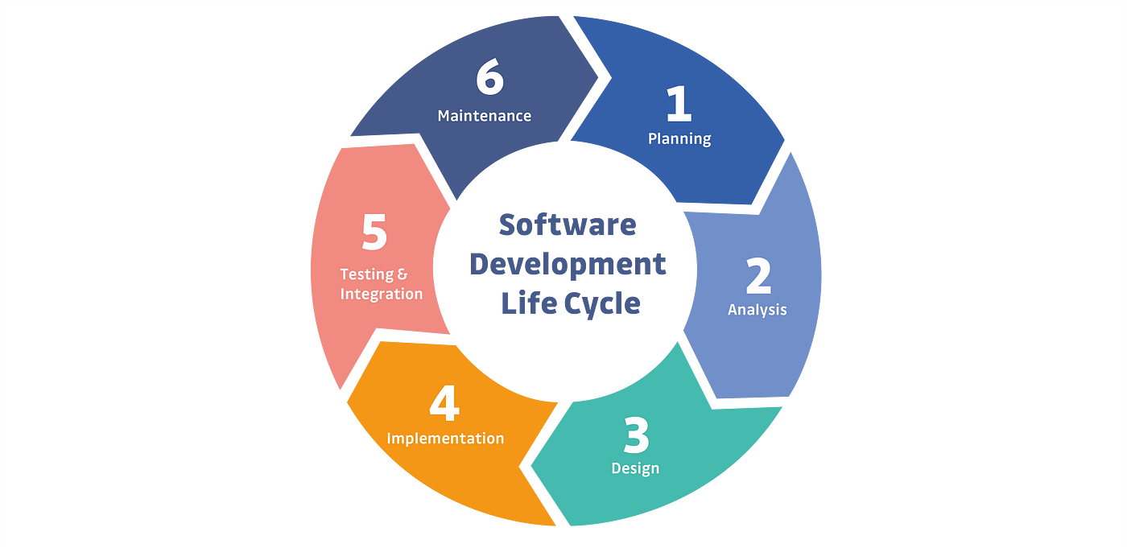

Here's a breakdown of software development life cycle (SDLC) for facial recognition attendance system software, considering both Waterfall and Agile approaches:

**1. Planning and Requirement Analysis:**

**Understand user needs:** Schools, offices, or security areas might have different needs (e.g., student attendance vs. employee access control).

**Define functionalities:** Features like capturing faces, storing data, attendance reports, and access control integration.

Consider legal and ethical implications of facial recognition technology.

**2. Defining Requirements:**

**Document technical requirements:** Hardware compatibility (camera, computer), software libraries for facial recognition, database type for storing facial data.

**Specify functional requirements:** Accuracy of recognition, handling errors (poor lighting, occlusions), reporting formats, user access levels.

**Define security protocols:** Encryption for storing facial data, access control for user management.

**3. Design (Waterfall) vs. Develop & Test (Agile):**

**Waterfall:** Design the system architecture thoroughly, including user interface mockups, data flow diagrams, and algorithms for facial detection and recognition.

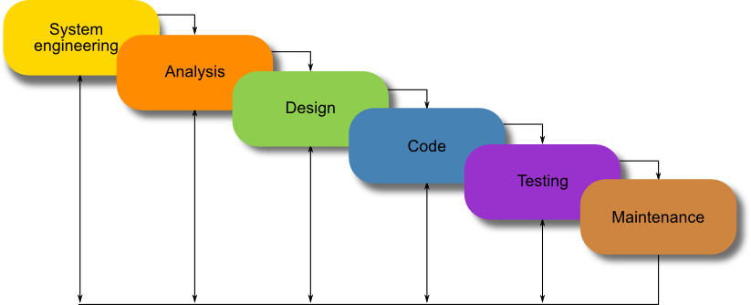

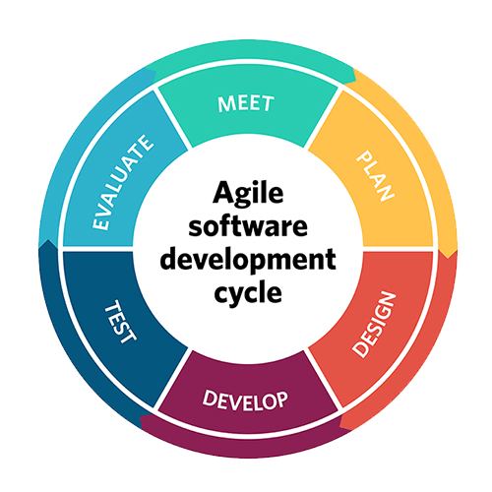**Agile:** Break down functionalities into smaller user stories. Develop core functionalities like user registration, facial capture, and basic attendance marking first.

**4. Development:**

Implement core functionalities based on the chosen approach (Waterfall or Agile). Integrate facial recognition libraries or develop custom algorithms if needed. Develop user interface for user interaction and data visualization.

**5. Testing:**

Unit testing of individual code modules. Integration testing to ensure different components work together seamlessly. Performance testing to measure accuracy, recognition speed, and system scalability. User Acceptance Testing (UAT) with real users to identify usability issues and ensure the system meets their needs.

**6. Deployment and Maintenance (Both Waterfall & Agile):**

Deploy the system to the target environment (on-premise server or cloud).

Provide user training on how to use the system effectively.

Ongoing maintenance to fix bugs, address security vulnerabilities, and potentially add new features based on user feedback (especially in Agile).

**Additional Considerations:**

**Data Security:** Implement strong encryption for storing facial data and enforce access control measures.

**Privacy:** Comply with data privacy regulations and obtain user consent for collecting and storing facial data.

**Scalability**: Design the system to accommodate a growing number of users and potential future features.

This is a general overview, and the specific SDLC approach (Waterfall, Agile, or a hybrid) can be chosen based on project size, team preferences, and desired level of flexibility.

1. **SRS (Software Requirement Specification)**

[**Product's purpose:**](https://www.perforce.com/blog/alm/how-write-software-requirements-specification-srs-document#purpose)

The primary purpose of a facial recognition attendance system is to automate and streamline the process of recording attendance within an organization. It achieves this by utilizing facial recognition technology to identify and verify individuals, eliminating the need for manual methods like sign-in sheets or badge swiping or ledger system.

[**Details of the requirements**](https://www.perforce.com/blog/alm/how-write-software-requirements-specification-srs-document#detail)**:**

**System requirements:**

Minimum requirements for a system to run this program are:

* Windows 7 or higher.
* 16 GB of RAM or higher.
* At least 128GB SSD/ hard disk or higher.
* Intel Core i3 processor or higher.
* Built-in webcam.
* You must be the administrator for your System.

**Functional requirements:**

* Data management
* Workflow and business logic
* Reporting and analytics
* User Authentication
* Audit tracking
* Historical data management

**7. Module Description**

**DFD**

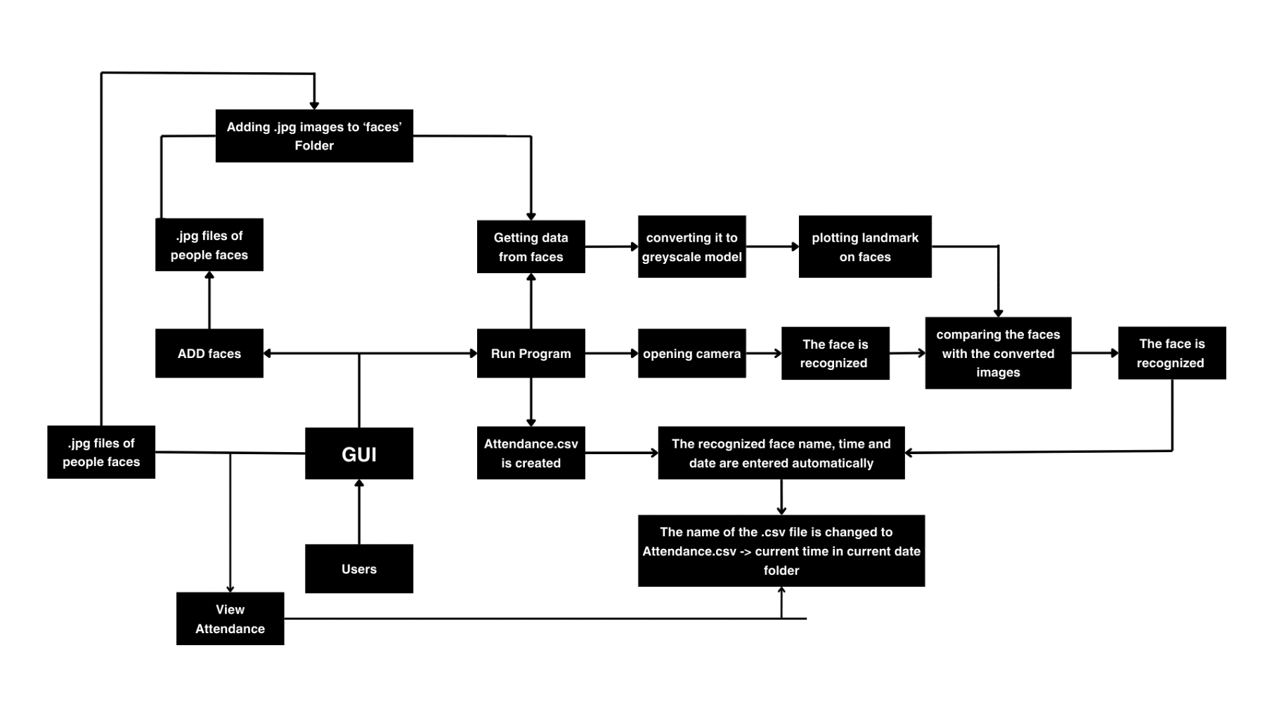The DFD (Data Flow Diagram) is based on the workflow of the program.

**ER Diagram**

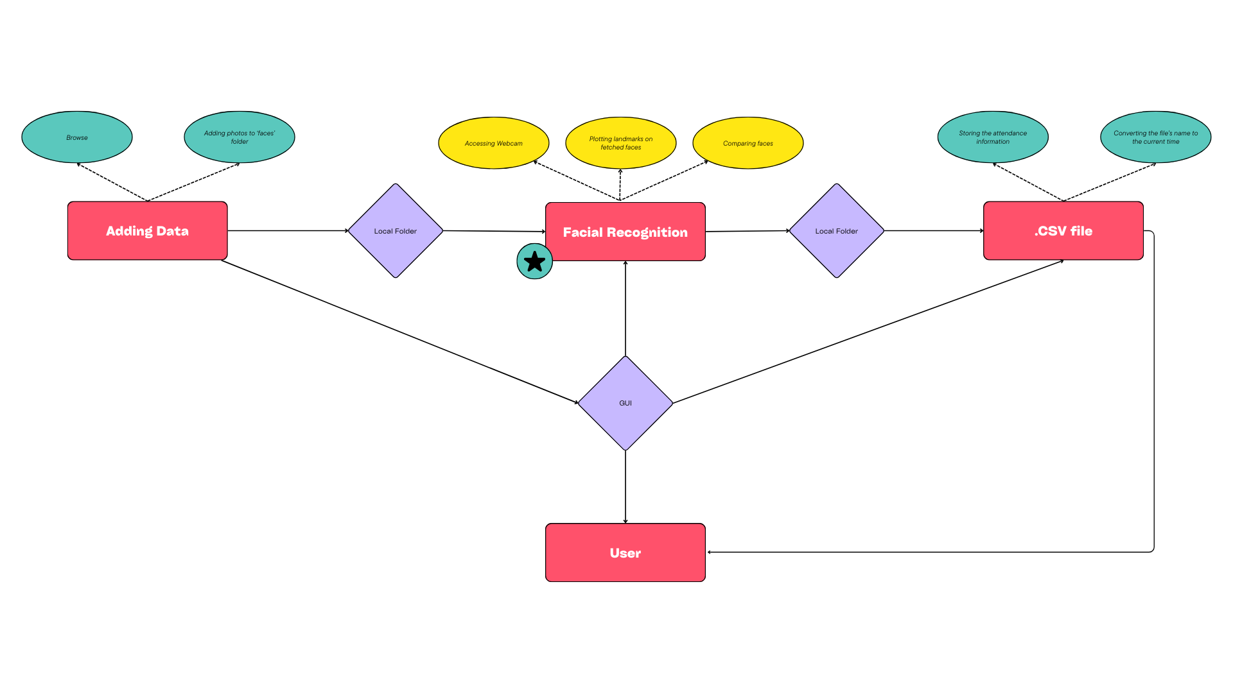Entity-Relationship (ER) Model for Facial Recognition Attendance System:

**Entities:**

User: Represents individuals using the system.

**Attributes:**

Name

Time

Date

**Facial Data:** Stores facial information for recognition.

**Attributes:**

Facial Data ID (Primary Key)

User ID (Foreign Key references User. User ID)

Encoded Face Data (Binary data representing facial features)

Attendance Event: Records attendance information.

**Relationships:**

One User can have Many Facial Data entries: A user can have multiple facial registrations for improved recognition accuracy. (1: N relationship between User and Facial Data)

One User participates in Many Attendance Events: A user can have many attendance records over time. (1: N relationship between User and Attendance Event)

**Benefits of this ER Model:**

* Clearly defines the data entities and their relationships.
* Provides a foundation for database design.
* Helps identify data requirements for the system.

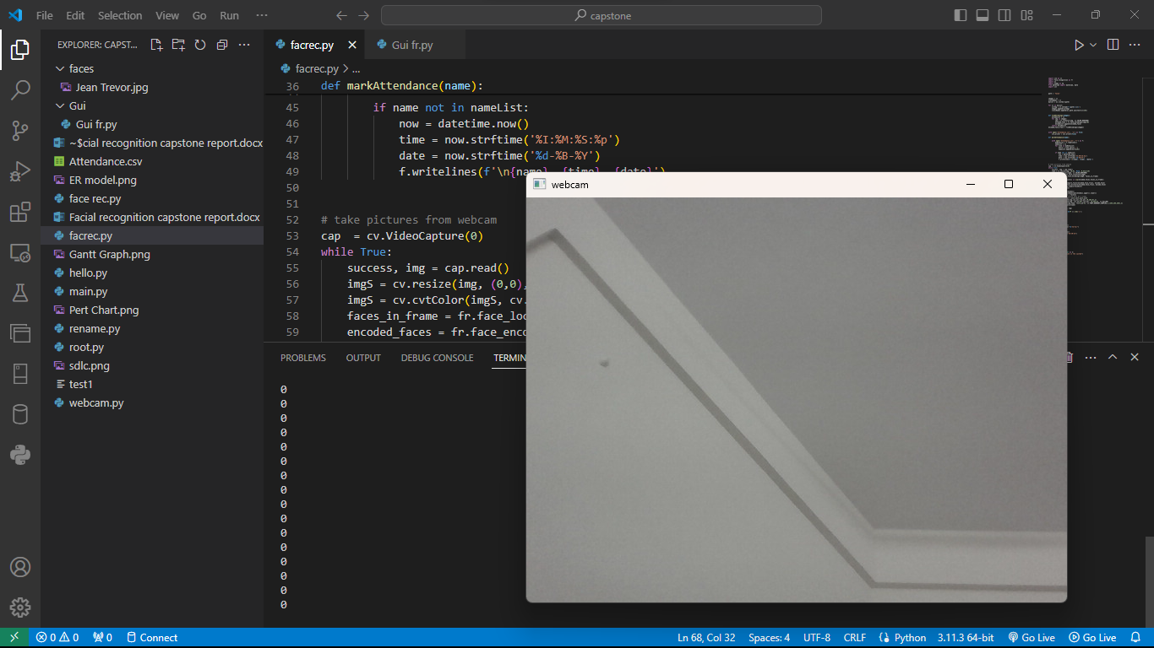**Testing**

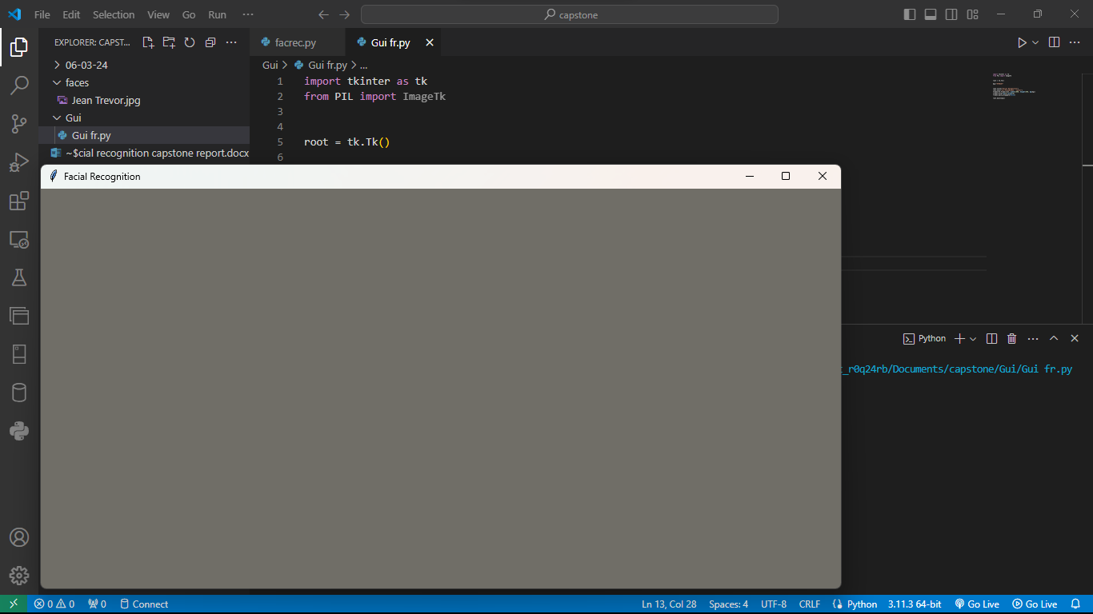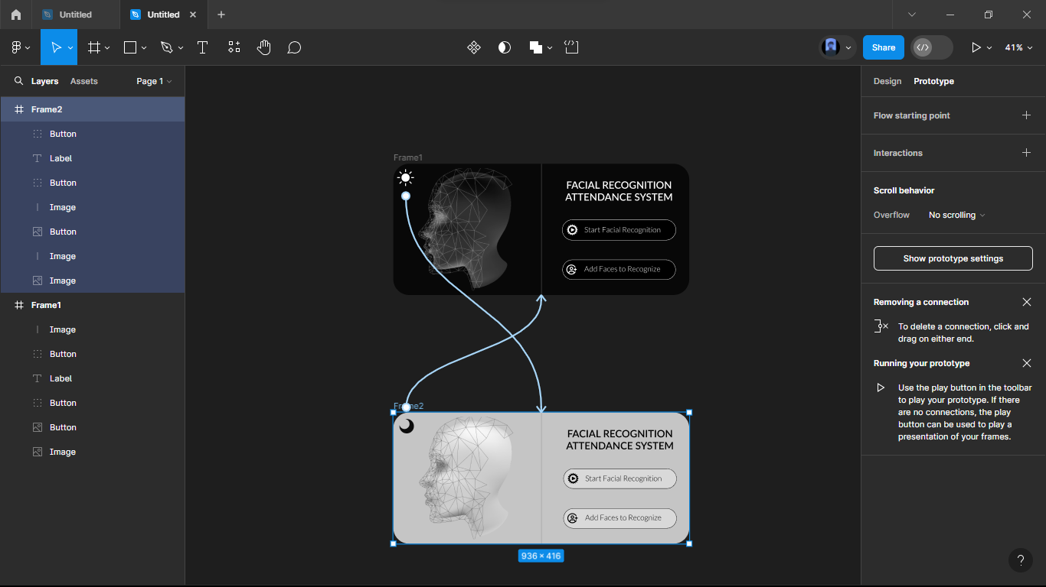**UI testing:**

**Data validation checks**

**Implementation**

import os

import csv

import shutil

import cv2 as cv

import webbrowser

import numpy as np

import tkinter as tk

import face_recognition as fr

from pathlib import Path

from tkinter import filedialog

from datetime import datetime, date

from tkinter import Tk, Canvas, Button, PhotoImage

window = Tk()

window.geometry("987x577")

window.resizable(False, False)

window.configure(bg = "#000000")

window.title("Facial Recognition System")

ti = PhotoImage(file='assets\\title\log.png')

window.iconphoto(False, ti)

#Facial recognition Attendance system

def mainprog():

    path = 'assets\\faces'

    images = []

    classNames = []

    mylist = os.listdir(path)

    for cl in mylist:

        curImg = cv.imread(f'{path}/{cl}')

        images.append(curImg)

        classNames.append(os.path.splitext(cl)[0])

    class frs():

        try:

            def findEncodings(images):

                encodeList = []

                for img in images:

                    img = cv.cvtColor(img, cv.COLOR_BGR2RGB)

                    encoded_face = fr.face_encodings(img)[0]

                    encodeList.append(encoded_face)

                return encodeList

            encoded_face_train = findEncodings(images)

            with open('Attendance.csv', 'w') as file:

                csv_writer = csv.writer(file)

            def markAttendance(name):

                with open('Attendance.csv','r+') as f:

                    myDataList = f.readlines()

                    nameList = []

                    for line in myDataList:

                        entry = line.split(',')

                        nameList.append(entry[0])

                    if name not in nameList:

                        now = datetime.now()

                        time = now.strftime('%I:%M:%S:%p')

                        date = now.strftime('%d-%B-%Y')

                        f.writelines(f'\n{name}, {time}, {date}')

            # Take pictures from webcam

            cap = cv.VideoCapture(0)

            while True:

                success, img = cap.read()

                imgS = cv.resize(img, (0,0), None, 0.25,0.25)

                imgS = cv.cvtColor(imgS, cv.COLOR_BGR2RGB)

                faces_in_frame = fr.face_locations(imgS)

                encoded_faces = fr.face_encodings(imgS, faces_in_frame)

                for encode_face, faceloc in zip (encoded_faces, faces_in_frame):

                    matches = fr.compare_faces(encoded_face_train, encode_face)

                    faceDist = fr.face_distance(encoded_face_train, encode_face)

                    matchIndex = np.argmin(faceDist)

                    print(matchIndex)

                    if matches[matchIndex]:

                        name = classNames[matchIndex].upper().lower()

                        y1,x2,y2,x1 = faceloc

                        # since we scaled down by 4 times

                        y1, x2,y2,x1 = y1*4,x2*4,y2*4,x1*4

                        cv.rectangle(img,(x1,y1),(x2,y2),(0,255,0),2)

                        cv.rectangle(img, (x1,y2-35),(x2,y2), (0,255,0), cv.FILLED)

                        cv.putText(img,name, (x1+6,y2-5), cv.FONT_HERSHEY_COMPLEX,1,(255,255,255),2)

                        markAttendance(name)

                cv.imshow ('Press "X" and the close', img)

                if cv.waitKey(1) & 0xFF == ord('x'):

                    break

        except Exception as e:

            print ("Folder contains non-face images.")

    exit

    try:

        c="Attendance/"

        today = date.today()

        d1 = today.strftime("%d-%m-%y/")

        f = str(d1)

        time = datetime.now()

        d2 = time.strftime("%H-%M-%S")

        cc = str(d2)

        cfn2 = c+f+cc

        cfn = str(cfn2)

        s='Attendance.csv'

        d= cfn+ '.csv'

        os.renames (s,d)

        print("Attendance updated to -> "+d)

    except:

        window = Tk()

        window.geometry("987x577")

        window.configure(bg = '#000000')

        window.title("Facial Recognition System")

        w = tk.Label(window, text="You have uploaded non-face images.\n Please delete it.",

                     font= ("Lato SemiBold", 32 * -1), bg='black', fg='white')

        w.pack()

#Adding Faces to recognize

def af():

    try:

        filename =filedialog.askopenfilename(

            filetypes= (("jpg files","*.jpg"), ("jpeg files","*.jpeg"))

            )

        filepath=os.path.abspath(filename)

        srcpath=str(filepath)

        shutil.copy(srcpath,'assets\\faces')

    except:

        print ("No image selected")

exit

OUTPUT_PATH = Path(__file__).parent

ASSETS_PATH = OUTPUT_PATH / Path(r"assets\frame0")

def relative_to_assets (path: str) -> Path:

    return ASSETS_PATH / Path(path)

canvas = Canvas (

    window,

    bg = "#000000",

    height = 577,

    width = 987,

    bd = 0,

    highlightthickness = 0,

    relief = "ridge"

)

canvas.place(x = 0, y = 0)

#Images

image_image_1 = PhotoImage (

    file=relative_to_assets("image_1.png"))

image_1 = canvas.create_image (

    759.0,

    288.0,

    image=image_image_1

)

image_image_2 = PhotoImage(

    file=relative_to_assets("image_2.png"))

image_2 = canvas.create_image (

    70.0,

    288.0,

    image=image_image_2

)

#Buttons

button_image_1 = PhotoImage (

    file=relative_to_assets("button_1.png"))

button_1 = Button (

    image=button_image_1,

    borderwidth=0,

    bg='black',

    highlightthickness=0,

    command=lambda: webbrowser.open('assets\\faces'),

    relief="flat"

)

button_1.place(

    x=133.0,

    y=422.0,

    width=361.0,

    height=89.0

)

button_image_2 = PhotoImage (

    file=relative_to_assets("button_2.png"))

button_2 = Button (

    image=button_image_2,

    borderwidth=0,

    bg='black',

    highlightthickness=0,

    command=lambda: webbrowser.open('Attendance'),

    relief="flat"

)

button_2.place(

    x=133.0,

    y=303.0,

    width=361.0,

    height=88.0

)

button_image_3 = PhotoImage (

    file=relative_to_assets("button_3.png"))

button_3 = Button (

    image=button_image_3,

    borderwidth=0,

    bg='black',

    highlightthickness=0,

    command=af,

    relief="flat"

)

button_3.place(

    x=133.0,

    y=183.00006103515625,

    width=361.0,

    height=89.0

)

button_image_4 = PhotoImage(

    file=relative_to_assets("button_4.png"))

button_4 = Button(

    image=button_image_4,

    borderwidth=0,

    bg='black',

    highlightthickness=0,

    command=mainprog,

    relief="flat"

)

button_4.place(

    x=133.0,

    y=65.0,

    width=361.0,

    height=88.0

)

window.mainloop()

**Security measures taken**

**Cost estimation of the project**

A typical project estimate will be made up of the following components

* **Tasks –** what’s going to be done
* **Resources –** Who’s going to be doing it
* **Duration –** how long it will take
* **Rate –** how much will it cost to deliver the project
* **Tools and software –** what tools and software will be needed for the project

Estimation of cost according to the above-mentioned format,

* **Tasks –** Creating or training a machine to recognize faces and mark attendance by recognizing.
* **Resources -** A team of 3 members built this Facial recognition Attendance system project.r
* **Duration –** This project took over 3 months to build it.
* **Rate –** This project may cost over a $300 to deliver.
* **Tools & Software used –** Windows, Python, Excel, Canva.

The total money spent to build this project is $0 but if you don’t have a webcam in your system you have to buy it which may cost around $50.

**Maintenance**

Maintaining a facial recognition attendance system is crucial to ensure its smooth operation, accuracy, and security. Here are some key aspects of Facial recognition Attendance system maintenance:

**Hardware Maintenance:**

**Regular cleaning:** Regularly clean the camera lens and other hardware components to ensure optimal image quality and prevent dust build-up.

**System checks:** Conduct periodic checks of the system hardware for any signs of wear and tear or malfunctioning components.

**Software updates:** Keep the Facial recognition Attendance system software updated with the latest patches and security fixes to address vulnerabilities and improve performance.

**Data Management:**

**Data backups:** Regularly back up the facial recognition database and other system data to prevent data loss in case of technical issues.

**Data accuracy:** Regularly review the stored facial data for accuracy and update it if necessary due to changes in appearance (e.g., new hairstyle, glasses).

**Data deletion:** Establish procedures for deleting outdated or unused facial data according to data privacy regulations and organizational policies.

**System Performance Monitoring:**

**Accuracy checks:** Periodically conduct accuracy checks to ensure the system is correctly identifying individuals. This can involve running test scenarios or user feedback.

**Log monitoring:** Monitor system logs for any errors, warnings, or unusual activity to identify potential issues and ensure smooth operation.

**Security audits:** Conduct regular security audits to identify and address any vulnerabilities in the system or data storage practices.

**User Management:**

**User training:** Train users on the proper use of the Facial recognition Attendance system, including enrollment procedures, best practices for accurate identification, and reporting any issues.

**User access control**: Implement access control measures to restrict unauthorized access to the system and manage user permissions effectively.

**User feedback:** Encourage users to provide feedback on their experience with the Facial recognition Attendance system and consider their suggestions for improvement.

By following these maintenance practices, organizations can ensure their Facial recognition Attendance system functions effectively, accurately, and securely, while maintaining user trust and data privacy.

**Limitations**

Facial recognition attendance system, while offering various advantages, come with limitations that need to be considered:

**Accuracy and Reliability:**

**Environmental factors:** Poor lighting, variations in facial expressions, angles, and occlusions (e.g., masks, glasses) can hinder accurate facial recognition.

**Database quality:** The accuracy of Facial recognition Attendance system relies heavily on the quality and completeness of the facial recognition database.

**Bias and discrimination:** Concerns exist about potential bias in facial recognition algorithms, leading to inaccurate identification, particularly for individuals from certain demographics.

**Privacy and Security:**

**Data collection and storage:** The collection and storage of facial recognition data raise privacy concerns, requiring careful data management practices and user consent.

**Potential for misuse:** Unauthorized access to or misuse of facial recognition data can pose security risks and privacy violations.

**Employee concerns:** Some employees may feel uncomfortable with the constant monitoring and data collection inherent in Facial recognition Attendance system.

**Technical and Practical Limitations:**

**Cost:** Implementing and maintaining Facial recognition Attendance system can be expensive, especially for larger organizations.

**Scalability:** Scaling Facial recognition Attendance system effectively for large numbers of individuals can be challenging, requiring robust infrastructure and efficient algorithms.

**Integration with existing systems:** Integrating Facial recognition Attendance system with existing attendance or payroll systems might require additional resources and technical expertise.

**Ethical Considerations:**

**Employee consent:** Obtaining informed consent from employees and ensuring transparency about data collection and usage is crucial.

**Regulatory compliance:** Organizations implementing Facial recognition Attendance system need to comply with relevant data privacy regulations and laws.

**Potential for social control:** The widespread use of Facial recognition Attendance system raises concerns about potential misuse for social control and mass surveillance.

**Future enhancements**

The future of facial recognition attendance system is expected to see advancements in several areas, addressing some of the current limitations and expanding their capabilities:

**Enhanced Accuracy and Performance:**

**Improved algorithms:** Advancements in artificial intelligence (AI) and machine learning (ML) are expected to lead to more robust algorithms with higher accuracy in recognizing faces under diverse lighting, angles, and even with partial occlusions (e.g., masks, sunglasses).

**Liveness detection:** Integration of liveness detection features can help ensure that a real person is present, preventing spoofing attempts with photos or videos.

**Multi-factor authentication:** Combining facial recognition with other factors, such as voice recognition or iris scans, can further enhance security and accuracy.

Privacy and Security Improvements:

**Differential privacy:** This technique can anonymize data while still allowing for accurate attendance tracking, providing a balance between security and privacy.

**Secure data storage and access control:** Implementing robust data security measures like encryption and access control mechanisms can mitigate the risks of unauthorized access and data breaches.

**User control over data:** Providing users with control over their data, including the ability to view, modify, and delete their facial recognition information, can address privacy concerns.

**Integration and Functionality Expansion:**

**Integration with existing systems:** Seamless integration with existing HR, payroll, and access control systems can streamline processes and enhance overall functionality.

**Advanced analytics:** Utilizing facial recognition data for advanced analytics, such as identifying trends in employee work patterns or well-being indicators, could offer valuable insights for organizational improvements.

**Multimodal attendance options:** Offering alternative attendance options, like voice or gesture recognition, alongside facial recognition, can cater to individual preferences and accessibility needs.

**Ethical Considerations and Transparency:**

**Clear and transparent communication:** Organizations should openly communicate about the purpose and methods of data collection, storage, and usage to build trust with employees.

**Strong ethical guidelines:** Establishing clear ethical guidelines around the use of Facial recognition Attendance system, considering data privacy, employee consent, and responsible data management, is crucial.

**Regular reviews and assessments:** Regularly reviewing and evaluating the impact of Facial recognition Attendance system on employees, addressing any potential biases or unintended consequences, can ensure responsible implementation.

By addressing limitations and focusing on ethical considerations, future Facial recognition Attendance system have the potential to become even more accurate, secure, and user-friendly tools for attendance management while respecting individual privacy and upholding ethical principles.

**Bibliography**

[*https://www.youtube.com/*](https://www.youtube.com/)

[*https://www.analyticsvidhya.com/blog*](https://www.analyticsvidhya.com/blog)

[*https://stackoverflow.com/*](https://stackoverflow.com/)

[*https://www.google.com/*](https://www.google.com/)

[*https://blog.enterprisedna.co/*](https://blog.enterprisedna.co/)

[*https://docs.python.org/*](https://docs.python.org/)

[*https://realpython.com/pysimplegui-python/*](https://realpython.com/pysimplegui-python/)

[*https://www.geeksforgeeks.org*](https://www.geeksforgeeks.org)

[*https://datascience.stackexchange.com/*](https://datascience.stackexchange.com/)

[*https://support.microsoft.com/*](https://support.microsoft.com/)

[*https://www.almabetter.com/*](https://www.almabetter.com/)

[*https://www.programiz.com/*](https://www.programiz.com/)

*https://github.com/*

[*https://www.w3schools.com/*](https://www.w3schools.com/)